Analysis and Development Potential of Predictive Models for Energy Flows of Autonomous Hybrid Energy Systems
V D Berdonosov¹, G V Vasilev¹, A A Zhivotova¹
¹First affiliation, Faculty of Computer Technology, Komsomolsk–na–Amure State University, Komsomolsk–na–Amure, Komsomolsk–na–Amure 681013, Russia

E–mail: gordeyvasilev@gmail.com
Abstract. The article is devoted to the analysis and development potential for predictive models of energy flows of autonomous hybrid energy systems. The article considers the results of the analysis in the form of a morphological table and TRIZ–evolutionary map. The research defined the most promising in predicting energy flows are hybrid models that include more than one architecture. For example, DCNN + LSTM or MLP + LS–SVR. The authors intend to continue research in the direction of creating predictive models of wind energy flows for autonomous hybrid energy systems.
- Introduction
A hybrid system is an energy system consisting of several power sources (generators) that use at least two different technologies to generate electricity [1, 2, 3].
The technical challenges facing such systems can be divided into generation and storage of energy in a cost–effective way, and the use of renewable energy sources (RES). In turn, the use of RES can be divided into three options: to give preference to the use of RES, where it is locally available; to accumulate energy from RES, when RES are available; to use backup energy sources (sets of generators) to achieve the required level of service, when RES are not available or not enough [3].
The benefits of hybrid systems are most noticeable when used year–round. In this case, as a rule, in winter the main output of electricity is produced by wind turbines, and by solar modules in summer. Such systems open up opportunities to improve environmental safety and economy of fuel for diesel generators by ensuring its optimized operation under conditions of changing load schedule directly related to the consumption of electricity at different times of the day [3].
Hybrid systems efficiency can be improved by different approaches: structural and/or parametric optimization, control modules upgrade, etc. To verify either approach, models of input and output energy flows of hybrid systems are required. The importance of having the models is confirmed by the huge number of publications on this topic.
The analysis of more than three hundred references allowed identifying the most significant factors relating to energy flow models. These factors include types of energy flow models, artificial intelligence systems used, availability of the connection to the national power grid (see Table 1). By selecting the most significant references, the authors formed a morphological table with variants of factor realization (see Table 1). The most significant one is Energy Flow Models, which includes solar and wind energy models, as well as consumption models. Next is the factor “Artificial Intelligence Systems Used” with the most varied options (24 total options) from autoregressive integrated moving average (ARIMA) [16, 20] to adaptive neuro–fuzzy inference system (ANFIS) [2, 6, 14] collapsed to two options: machine learning and deep learning. And finally, the last factor is “Connection to the National Power Grid” represented by two options: autonomous (no connection) and connected. From the authors' point of view, the types of energy flow models of autonomous hybrid energy systems (AHES) are of the greatest interest.

Table 1. Morphological Table.
Factors | Var. 01 | Var. 02 | Var. 03 | Qty
Types of Energy Flow Models | Solar energy  [1, 3, 4, 7, 9, 11, 12, 19, 23] et seq. for a total of 38 | Wind energy  [5–2, 8–5, 10–7, 13, 14, 16, 18, 20, 24] et seq. for a total of 39 | Consumption  [6, 17, 21, 22] et seq. for a total of 22 | 3
Artificial Intelligence Systems Used | Machine Learning  [6, 8, 9, 12, 15, 16, 20] et seq. for a total of 48 | Deep Learning  [2, 3, 4, 5, 6, 7, 10, 13, 14, 16, 18, 19, 23] et seq. for a total of 103 |  | 2
Connection to the National Power Grid | Autonomous  [1, 23] et seq. for a total of 10 | Connected  [3, 4] et seq. for a total of 9 |  | 2
- Energy Flows of AHES
Let's consider factor “Types of Energy Flow Models”. Although there are up to ten [25] flows of incoming energy, the authors have chosen only two the most used ones: solar flux and wind energy flows.
Considering solar flux, it should be taken into account that energy is generated when solar radiation affects solar modules. However, researchers also consider other meteorological data when creating solar energy models: temperature [3, 4, 11, 19, 23], humidity [4, 11], precipitation [4, 19], cloud cover [4], duration of sunlight [11], atmospheric pressure [11], wind speed [4, 11], wind direction [11], etc. The same situation is with wind flow models, in which wind direction [8], atmospheric pressure [8], temperature [8], etc. are also taken into account in addition to wind speed [8, 14]. When creating consumption models, the following data are taken into account: temperature [22], heat load [22], solar radiation [22], wind speed [22], and humidity [22]. For all, energy flows sampling is also important that can vary from a day [3, 4, 22] to six–hour [11], hour [11, 14, 19] and, finally, fifteen minutes [8].
Considering factor “Artificial Intelligence Systems Used”, it should be kept in view that the case is about the systems used in creating energy flows models for hybrid energy systems. Machine learning systems include primarily ARIMA [16, 20], autoregressive integrated moving average extended (ARIMAX) [20], extreme gradient boosting (XGBoost) [15], support vector machine (SVM) [9, 23], LSV [23], extreme learning machine (ELM) [6, 8, 12, 16] and other. Deep learning systems are represented by a broader set of systems and include multilayer perceptron (MLP) [5, 18, 23], convolutional neural network (CNN) [3–10, 19], long term memory (LSTM) [4, 7, 10, 13, 19], radial basis function (RBF) [16], ANFIS [2, 6, 14] and other.
When analyzing machine learning systems, researchers have focused on quick problem solving at low computational costs [9, 15, 20], the use of wavelet function [2, 6, 8, 15], etc.
For deep learning models, researchers have focused on the number of layers more than two [3, 4, 8, 11], the use of clustering algorithm [23], as well as activation functions: scale exponential linear units (SELU) [3], rectified linear units (ReLU) [3, 19], sigmoid [11, 22, 23], etc.
Researchers have considered the issues of creating models both for autonomous HESs [1, 23] and HESs connected to public networks [3, 4]. Autonomous HESs use distributed generators [1], accumulator energy storage systems [1], and solar energy systems [1, 23]. In systems with connection to the national power grid [3], solar energy systems can also be used [1].
Variable renewable energy (VRE) forecasting affects a number of power system management operations, including scheduling, dispatching, real–time balancing, reserve requirements for the power grid, and issuing commands to run (block) compensating power supply in advance. By integrating forecasts from local VRE producers, grid operators can anticipate rapid changes in VRE generation to economically balance consumption and planned generation. This approach leads to lower fuel costs, generally increases the reliability of the power grid, and minimizes the cost of generating energy from renewable energy sources.
It should be noted that this problem has not yet been reliably solved. A large number of algorithms and software packages have been proposed, but there are no generally recognized “industry standards” for VRE (variable renewable energy) forecasting. In this regard, there is an urgent task to systematize and identify the most effective systems for modeling the energy flows of hybrid energy systems.
- Analysis Methodology
The Theory of Inventive Problem Solving (TRIZ), particularly the TRIZ–evolutionary approach, was used to analyze the factors and elements of the morphological table. This approach has shown to be highly effective in analyzing elements in a variety of knowledge domains. For example, in [26] object–oriented programming systems, in [27] automated control systems, in [28] coking systems were analyzed, and the analysis led to a number of inventions. The most complete TRIZ evolutionary approach is described in [29], which discusses the evolution of machine translation methods. This approach allowed identifying the most promising translation method at the moment, uneliminated contradictions of this method, and defining the most effective areas of research on machine translation systems.
The purpose of analysis is to systematize information about flow models to identify key areas and prospects for development. In order to achieve the goal, it is necessary to create and analyze a TRIZ evolutionary map.
Briefly, the process of TRIZ evolutionary map creating consists of the following stages: description of an initial object (system) of TRIZ evolution; identification of contradictions in the object; definition of TRIZ tools allowing to eliminate the identified contradictions; description of TRIZ evolution iterations, i.e., transition to subsequent objects in which certain contradictions are eliminated. The above steps are repeated until a system with maximum ideality (in the TRIZ sense) which, nevertheless, also has contradictions, is achieved. Let's proceed to the TRIZ evolution of solar flux predictive models.
- TRIZ Evolution of Solar Flux Models
To conduct the TRIZ evolutionary analysis, first of all, main parameters shall be identified. The authors identified the following main parameters: error, computational costs, sample size, resiliency (error values as per environment variability), volume of input data, volume of input data highly correlating (app. 70%) with other input data, prediction time range, time range of data collection, duration of training, number of layers, number of hidden layers, number of neurons, number of hidden neurons.
The initial model in the analysis is the recurrent neural network (RNN) LSTM “RNN LSTM” [4]. Recurrent neural networks contain feedbacks to store information. An LSTM network is a special type of RNN capable of learning long–term dependencies that is specifically designed to solve problems related to such dependencies. All RNNs are in the form of a chain of repeating modules. The repeating module of standard RNN has a very simple structure, such as a single tanh layer and a hyperbolic tangent activation function. LSTM network is a similar chain, but contains four layers instead of one.
Four contradictions can be defined in RNN LSTM. Con1.1: with improving model resiliency, the sample size unacceptably increases. Con1.2: with improving model resiliency by sample size increase, the duration of training time unacceptably increases. Con1.3: with improving model resiliency by sample size increase, computational costs unacceptably increase. Con1.4: with reducing sample size by lower volume of input data, the error unacceptably increases.
Some of these contradictions (Con1.2, Con1.4) was eliminated by the Principle of Anti–Weight (8), Principle of Equipotentiality (12), Principle of Homogeneity (33) and Principle of Dynamics (15) [30]. The concept of distributing weights and step was added to the network, it has become more efficient at capturing the relationship between related data, and as the weights have become shared, less input data are required. The first iteration of the TRIZ evolution and transition to CNN PVPNet model performed [3].
The users' demand for fewer layers and larger sample size has led to further contradictions in CNN PVPNet. Con2.1: with decreasing number of layers the error unacceptably increases. Con2.2: with increasing sample size the duration of training unacceptably increases.
Contradiction Con2.1 was eliminated by the Principle of Dynamics (15). An algorithm was added to the network to determine the optimal number of neurons in the hidden layer. The second iteration of the TRIZ evolution and transition to artificial neural network (ANN) MLP “ANN MLP” performed [11].
User's requirement to reduce the error by increasing the volume of input data has led to another contradiction in ANN MLP model. Con3.1: when reducing the error by increasing the volume of input data, the volume of input data highly correlating with other input data unacceptably increases.
Contradiction Con3.1 was eliminated by the Principle of Merging (5). Merging two architectures allows optimizing the performance with reduced memory requirements, and filters separate data with features of different lengths. The third iteration of the TRIZ evolution and transition to a hybrid model of CNN deep convolutional neural networks (DCNN) and RNN LSTM “CNN D–CNN & RNN LSTM” performed [19].
User's requirement to reduce the error by increasing the number of layers led to another contradiction in CNN D–CNN & RNN LSTM model. Con4.1: when reducing the error by increasing the number of layers computational costs unacceptably increase.
Contradiction Con4.1 was eliminated by the Principle of Merging (5) and Principle of Intermediary (24). This model uses an intermediate clustering method in order to exclude input data values that increase error. Merging two architectures allows reducing the error by choosing the best result among the models. The fourth iteration of the TRIZ evolution and transition to a complex, final hybrid model of ANN MLP and SVM least squares support vector regression (LSSVR) “ANN MLP & SVM LS–SVR” performed [23].
Figure 1 shows the TRIZ evolutionary map noting the key changes in the models. Figure 1 also shows transitions from RNN LSTM to ANN MLP & SVM LS–SVR and to CNN D–CNN & RNN LSTM, as well as the transition from ANN MLP to ANN MLP & SVM LS–SVR.
- Analysis of the TRIZ Evolutionary Map
Of course, the main parameter for evaluating models created on the basis of artificial intelligence is errors. It should be noted that the error estimate varies from model to model. In the first models it is a training error which is the difference between the desired (target) value and the actual value of the model output on examples of the training set. Training error is a measure of the accuracy of the model setting on a training set. However, it does not allow us to evaluate the model accuracy as per new data not used while training, i.e., the model generalization ability. Therefore, subsequent models use generalization error, i.e., the error as per a test set.
Note that as the models improve (moving up the TRIZ evolutionary map), the law of transition to a supersystem is clearly discernible [31]. According to this law, as the system runs out of resources, it merges with other systems that previously competed with it. This indicates a direction for further models’ improvement considering the contradictions in the final system: with decreasing number of input parameters the error unacceptably increases (Con5.1).
- Models Development Potential
The analysis of the TRIZ evolutionary map allowed us to define the following areas of research:
conduct a similar analysis of wind energy and consumption energy predictive models; identify the most efficient architectures in these models; analyze the possibility of integrating these architectures into the final hybrid model explore the possibility of replacing individual architectures in the final model; for example, replacing the MLP architecture in the final model with the LSTM architecture which uses layers with memory in time series processing.

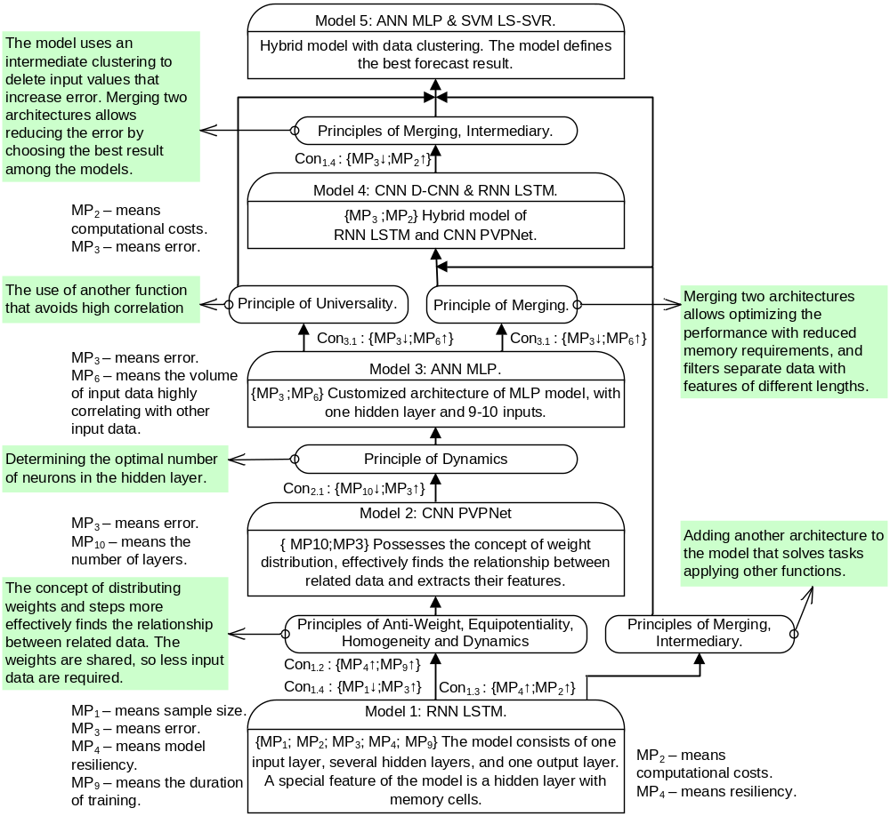
Figure 1. TRIZ Evolutionary Map of Solar Flux Predictive Models.
- Conclusion
The TRIZ evolutionary approach to the analysis of solar flux predictive models allowed us to systematize and visualize the data on the models’ evolution; to describe main performance parameters that determine models’ development potential; to identify promising directions of models’ improvement.
The main result of this analysis is the identification of promising directions for the models’ improvement, many of which lie in the area of merging artificial intelligence architectures. As per the authors opinion, the greatest research interest is in solving the problem of reducing computational costs while maintaining the value of error. Indirectly, this problem can be solved by replacing individual architectures in the final ANN MLP & SVM LS–SVR model.
- References
[1] Zhuo W, Wenhao A V and Meng K 2019 Decentralized optimal control of a microgrid with solar PV, BESS and thermostatically controlled loads Energies 12
[2] Panapakidis I P, Michailides C and Angelides D C 2019 A data–driven short–term forecasting model for offshore wind speed prediction based on computational intelligence Electronics (Switzerland) 8
[3] Huang C–J and Kuo P–H 2019 Multiple–input deep convolutional neural network model for short–term photovoltaic power forecasting IEEE Access 7 74822–34
[4] Jeon B–K and Kim E–J 2020 Next–day prediction of hourly solar irradiance using local weather forecasts and LSTM trained with non–local data Energies 13
[5] Medina S V and Ajenjo U P 2020 Performance improvement of artificial neural network model in short–term forecasting of wind farm power output J. of Modern Power Systems and Clean Energy 8 484–90
[6] AL–Musaylh M S, Deo R C and Li Y 2020 Electrical energy demand forecasting model development and evaluation with maximum overlap discrete wavelet transform–online sequential extreme learning machines algorithms Energies 13
[7] Maitanova N, Telle J–S, Hanke B, Grottke M, Schmidt T, Von Maydell K and Agert C 2020 A machine learning approach to low–cost photovoltaic power prediction based on publicly available weather reports Energies 13
[8] Tan L, Han J and Zhang H 2020 Ultra–short–term wind power prediction by salp swarm algorithm–based optimizing extreme learning machine IEEE Access 8 44470–84
[9] Dong J, Wu L, Liu X, Fan C, Leng M and Yang Q 2020 Simulation of daily diffuse solar radiation based on three machine learning models CMES – Computer Modeling in Engineering and Sciences 123 49–73
[10] Sun Y, Wang P, Zhai S, Hou D, Wang S and Zhou Y 2020 Ultra short–term probability prediction of wind power based on LSTM network and condition normal distribution Wind Energy 23 63–76
[11] Notton G, Voyant C, Fouilloy A, Duchaud J L and Nivet M L 2019 Some applications of ANN to solar radiation estimation and forecasting for energy applications Appl. Sci. (Switzerland) 9
[12] Hou M, Zhang T, Weng F, Ali M, Al–Ansari N and Yaseen Z M 2018 Global solar radiation prediction using hybrid online sequential extreme learning machine model Energies 11
[13] López E, Valle C, Allende H, Gil E and Madsen H 2018 Wind power forecasting based on echo state networks and long short–term memory Energies 11
[14] Fazelpour F, Tarashkar N and Rosen M A 2016 Short–term wind speed forecasting using artificial neural networks for Tehran, Iran Int J. of Energy and Environ Eng 7 377–90
[15] Ahmadi A, Nabipour M, Mohammadi–ivatloo B, Amani A M, Rho S and Piran M J 2020 Long term wind power forecasting using tree–based learning algorithms IEEE Access 8 151511–22
[16] Sun N, Zhang S, Peng T, Zhou J and Sun X 2020 A composite uncertainty forecasting model for unstable time series: application of wind speed and streamflow forecasting IEEE Access 8 209251–66
[17] Zhang P, Ma X and She K 2019 Forecasting Japan's solar energy consumption using a novel incomplete Gamma Grey Model Sustainability (Switzerland) 11
[18] Manero J, Béjar J and Cortés U 2019 «Dust in the wind...», deep learning application to wind energy time series forecasting Energies 12
[19] Lee W, Kim K, Park, J, Kim J and Kim Y 2018 Forecasting solar power using long–short term memory and convolutional neural networks IEEE access 6 73068–80
[20] Zhao E, Zhao J, Liu L, Su Z and An N 2016 Hybrid wind speed prediction based on a selfadaptive ARIMAX model with an exogenous WRF simulation Energies 9
[21] Marzouk M and Alaraby M 2015 A multi time scalewind power forecasting model of a chaotic echo state network based on a hybrid algorithm of particle swarm optimization and tabu search J. of Civil Engineering and Management 21 67–74
[22] Potočnik P, Strmčnik E and Govekar E 2015 Linear and neural network–based models for short–term heat load forecasting Strojniški vestnik – J. of Mechanical Engineering 61 543–50
[23] Quintián H, Calvo–Rolle J L and Corchado E 2014 A hybrid regression system based on local models for solar energy prediction Informatica (Netherlands) 25 265–82
[24] Feng C, Cui M, Hodge B–M and Zhang J 2017 A data–driven multi–model methodology with deep feature selection for short–term wind forecasting Applied Energy 190 1245–57
[25] Berdonosov V D, Shamak V A, Zivotova A A and Zheltov M V 2019 Hybrid Power Systems optimization for Regions of the Far North IEEE Access
[26] Berdonosov V D and Zhivotova A A The evolution of the object–oriented programming languages Procedia Engineering 1 35–43
[27] Berdonosov V D and Zhivotova A A 2015 Perspectives for development of automatized enterprise management systems IEEE Access 154–63
[28] Berdonosov V D, Kozlita A N and Zhivotova A A 2015 TRIZ evolution of black oil coker units J. Chem. Eng. Res. Des. 103 61–73
[29] Zhivotova A A, Berdonosov V D and Redkolis E V 2020 Machine Translation Systems Analysis and Development Prospects IEEE Access
[30] Altshuller G 1998 40 Principles: TRIZ Keys to Technical Innovation (Worcester: Technical Innovation Center) p 135
[31] Altshuller G 1999 The innovation algorithm: TRIZ, systematic innovation, and technical creativity (Worcester: Technical Innovation Center) p 289
[32] Gordin S, Kozlova O and Zaychenko I 2020 Using the capabilities of neural networks to adapt the parameters of PID regulation in automatic control systems of low–power boilers IEEE Access

